IT3037c
Lab#0.5: Amazon IAM and CLI User Set-up

In this lab, you will study Amazon IAM and set up the command line . You will use the AWS CLI and console to implement and deploy this.

Tools and Materials
- Ubuntu VM with AWS Credentials for the Command Line.
- AWS Console

In the following lab you will learn how to configure and install the AWS cli on your VM.

- Before we can configure the CLI we must go to the AWS console. After this you will see the following dashboard:
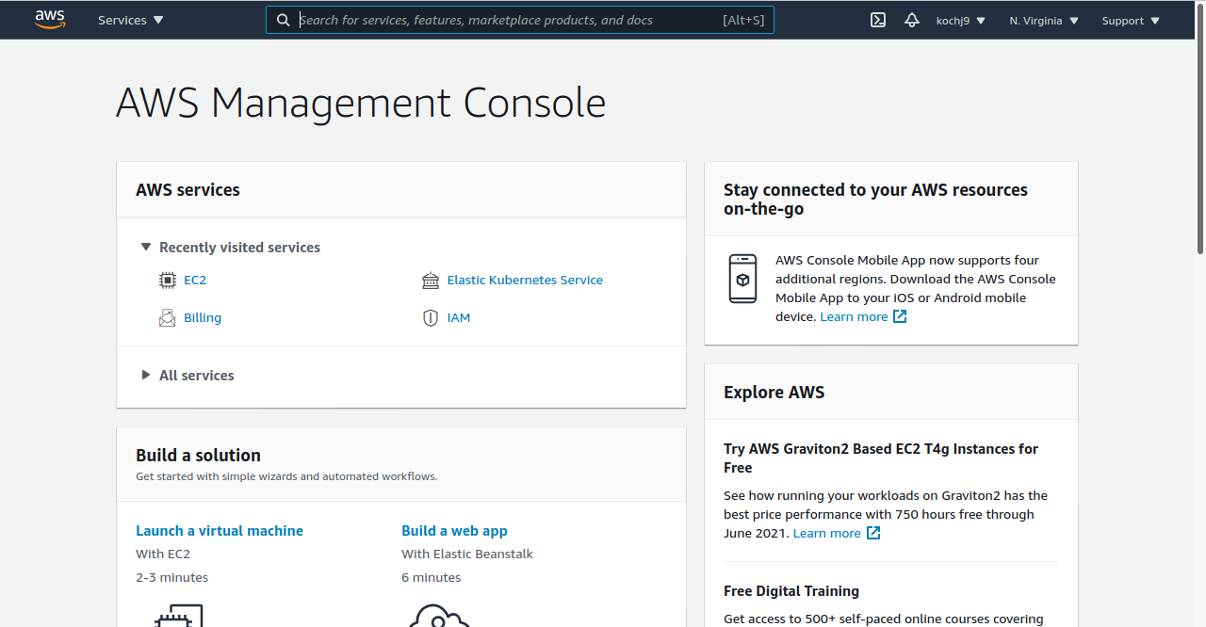
- Next, you must navigate to the IAM dashboard by searching “IAM” in the search bar at the top of the page. This should bring you to the IAM dashboard:
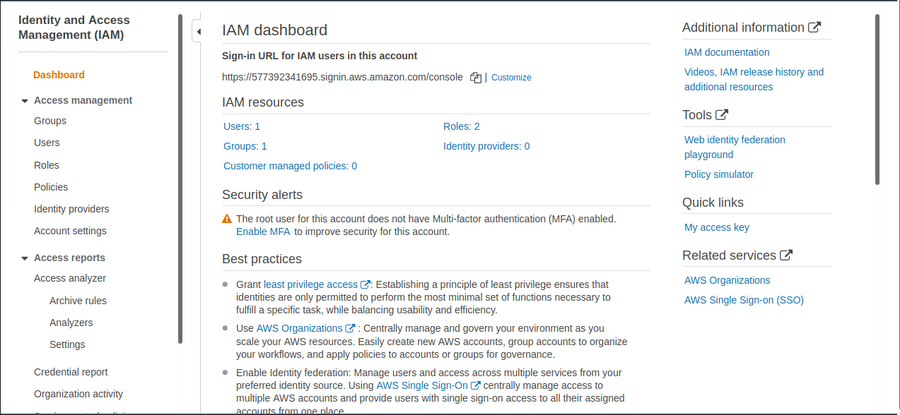

- To access the CLI we must create a user that can be configured to the CLI. To do this we must navigate to the users tab. Next we will create a user by clicking add user. Next, we will configure the users name and permissions. We want the user to have programmatic access so they can access all resources then click permissions:
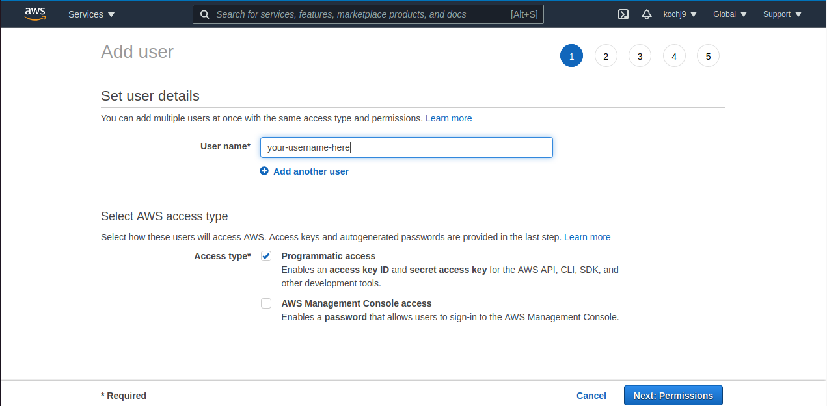

For permissions we want need to assign a role to our user so that they have unlimited access to do this click add user to group. Next click the administrator role then click create group:
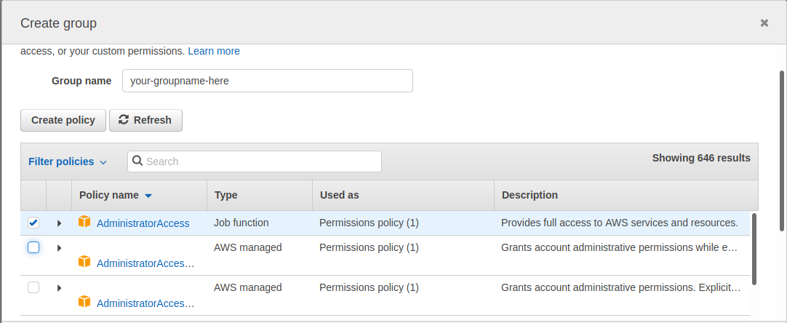
You can add tags to identify your user from others, but this is not necessary for us. Click next, and then next one more time to review your user. Verify your information is correct and then click create.

*Important*
This will create a user with an access key and secret key. Be sure to download the csv file for this user so that you will have access to your credentials later. If you lose this csv file you will have to create a new user if you want to reconfigure your CLI.

- To download the CLI first, we need to download the executable program for AWS. To do this, we enter the following curl command:
curl "https://awscli.amazonaws.com/awscli-exe-linux-x86_64.zip" -o "awscliv2.zip"
- Next, we need to unzip the executable, this is because all the files are downloaded into a zip file to save space, we do this with the following command:
unzip awscliv2.zip
- Following this we must finally install the CLI. We do this with the following command:
sudo ./aws/install
- Following this, we can test that the CLI was downloaded using the AWS version command
aws --version

What did you see? This command should tell you what version of AWS you have.
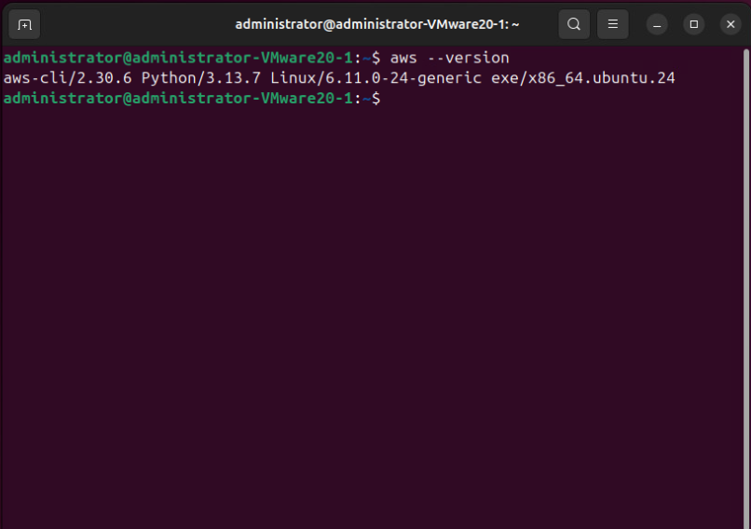
- Following this, we must now configure our AWS account to the AWS CLI. We do this by entering the following command:

aws configure

This will bring-up a prompt:

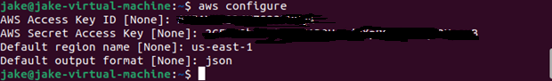
You will enter your access key information as well as your private key information. For the default region configure AWS to the us-east-1 region. For the default output format, enter json format, then hit enter.

Submission instruction

After completing this work, submit this word document with your answers to the Canvas. In your word document, your answers should be in blue print.

